- Description of Training & Learning Outcomes
T
he Training Module for Meena Radio has been developed for use by the trainers for training teachers to conduct the Meena Radio programme. Meena Radio is an entertainment education (EE) radio program for school children in classes 6 to 8 – and it requires a different approach for helping students gain the full benefits of this innovative initiative. The module provides the trainers with a standardized training guide to plan the training programme.

Meena Radio is an EE program that empowers children, especially girls, to build their self-esteem, so that they can help themselves and others in the community. The radio program is built around Meena, who is a nine year old spirited girl. She finds creative ways to tackle problems faced by her
Friends – and it is this creativity and the Life Skills aspects of the radio program that need to be dealt with by the teachers and which are a focus area of the training programmes.

The teachers play a vital role in the implementation of the programme and therefore they need to be trained to understand how a Meena Radio differs from regular classes at school and how they must conduct it. It is the teacher’s responsibility that children enjoy the radio broadcast and also learn new information on issues of child rights, gender equality and child-friendly schools -- and are able to discuss the same with their fellow students, parents, family and other community members.

Every episode of Meena Radio is 15-minutes long and altogether there are 160 episodes in the series available for broadcast – the states select how many of these would be chosen for broadcast in an academic year. Since the format of the program is EE, there is a song, a skit and a game in each episode. The training helps teachers to understand their roles and responsibilities before, during and after the radio program is broadcast. The radio program must be conducted in a way that it evokes emotions and engages the child’s imagination. This kind of a class must be seen as a unique opportunity by the students and their teachers to address practical issues that affect the lives of children and are not explored in such a manner through the regular courses at school.

The Training Module for Meena Radio has been developed to standardize the trainings for teachers, as well as provide trainers/teachers with a handy guide to use as a reference, so that the radio program can be presented in the manner that its impact can be maximized. By following the training process outlined in this book and by using the Teacher‘s Guidebook, available separately, trainers can help teachers to get an introduction to the content and format of the radio program and prepare them to present it properly to the children.

The training would help teachers understand how to support this exciting initiative for school children. We will cover:

- the objectives of Meena Radio
- the role of teachers
- and, the do’s and don’ts for teachers (before, during and after the Meena Radio broadcast).

Who to train? While for the training of Master Trainers it is preferable to have education and training authorities participating, it would be preferable to have teachers from classes 6 to 8 attend the teacher training. If teachers are chosen from classes in which the program is being implemented, they could be more involved in implementing the programme and could also emerge as its champions – strengthening its implementation through a bigger sense of ownership of it. They may also be more familiar with the needs and learning capabilities of children in classes 6 to 8. During the selection of teachers and trainers, there should also be an emphasis on ensuring 50:50 gender participation – this is important because typically the overall teacher strength is divided equally among the two genders and the programme must be equally understood and supported by both male and female teachers.
Training Design: Master Trainers will need to be trained to train the teachers. The Master Trainers will work in groups of two or three to cover the teacher trainings at the district level.
Ideally two -- but at least one -- teacher should be formally trained from each school in the manner outlined in this book. It is expected that these trained teachers would share their learnings with other teachers in their schools and communities. The teachers being trained should be equally from both genders and should be teaching classes 6 to 8. However, the states can decide the number of teachers to be trained depending on the average class strength and availability of teachers. In schools with a larger student population, it can be expected that students of each class would hear the radio programme separately – and therefore there would be a need to train three teachers.
Apart from the teachers, it is imperative that the headmasters or principals of the schools also get a short orientation about Meena Radio and how the radio program can bring lasting change to the entire school and the community at large. The headmasters can also be accommodated in the training for teachers, if it is found to be appropriate and cost-effective. Otherwise a separate Orientation for headmasters may be undertaken which would be facilitated by the Master Trainers. This Training Module can also serve, after the training, as a reference guide for the teachers trained and other teachers who they can share the training with.
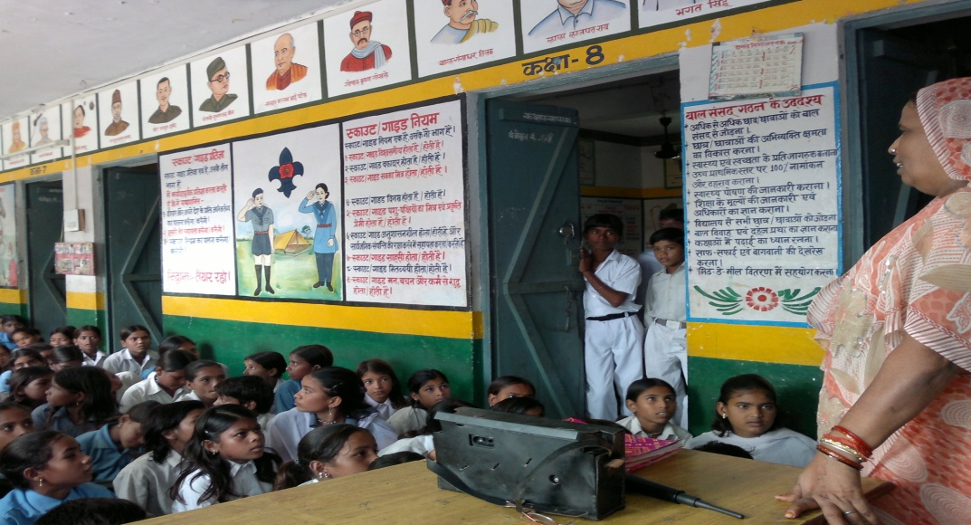
A trained teacher conducts a Meena Radio class in Lalitpur district in U.P.
The trained teacher is expected to coordinate and lead the programme in the school and village/ward. Training will be provided by Master Trainers selected by the Sarva Shiksha Abhiyan or other implementing partner/s at the onset of the programme in any district/state. The ideal size of trainees during a training session may be about 40, whereby participants can actively participate in the interactive training, which involves a lot of group work by the participants.
A Pre-training questionnaire can enable the trainers to understand the specific training needs of the participants and this could allow them to focus on specific aspects of the training during the session. A Post-training assessment will inform trainers and program managers of the progress made during the training and also identify any pending gaps that may need continued attention even after the training is completed.
While the Master Trainers are trained comprehensively over a two-day training, the training for teachers is completed in a duration of 8 hours, excluding the breaks for meals/refreshments. The details of each session are provided in the subsequent pages. The schedule for training trainers and teachers may be adjusted in a way that enables participants to interact and share more, rather than only listening to talks by the trainers. Breakouts, where participants share their stories or sing songs related to Meena Radio, will help the teachers to open up and start enjoying the new role set out for them for supporting an innovative program with a new pedagogy.
Learning Outcomes:
The training will enable teachers to conduct a Meena Radio class at their schools, informing them about the steps that they need to take prior to the broadcast, during the broadcast and following the broadcast to ensure that students are able to actively participate in the program. The training will also teach trainers to support the monitoring efforts during the implementation of the program. At the completion of this training, through the radio program, teachers should be able to:
- Stimulate the children’s motivation to learn
- Make learning interactive so that students can recall and share Meena Radio’s messages with family and friends
- Implement methods of conducting a class that facilitates discussion and enquiry
- Adapt teaching styles to various learning modalities
- Assess the needs of learners in terms of their experience, learning styles, interests and knowledge base and assist the children to enjoy the learning process
- Demonstrate the use of a variety of teaching techniques
- Create and maintain a learning environment that will promote success
- Monitor the progress of the programme and provide appropriate and timely feedback

- The methodology of the implementation of a class needs to be emphasized, especially the role of the teacher -- which in this case is more of a facilitator’s role who encourages students to think independently
- The need for preparations for the class, in terms of logistics -- including having working radio sets (and amplifiers in case it is a large class) available in time and the students seated before the broadcast begins -- needs to be emphasized too
- Teachers must be told to make boys feel as excited about Meena Radio as the girls, since it has learnings for both genders
- The training provided should be simple, easy to understand and remember
- Teachers should be able to adapt or add to the information provided here
- Teachers should understand the crucial role they play in ensuring that the children discuss the stories and issues after the program and / or in Meena Manch (or Meena Raju Manch) meetings and find innovative ways to discuss the same with other students, parents and other family members
- Remind teachers that their role is of prime importance and that it is through their involvement that children will learn how to solve problems in their daily life
- Teachers should be able to encourage activities even outside the class
- Training Schedule
T
he one-day-long teacher training consists of three main sessions. This Training Module covers the Registration, Welcome/Introductions and Introductory Activity (Ice Breaker), along with the three sessions of the training, providing a step-by-step guide to inform trainers. In each session, we look at six aspects: a) Session Objective, b) Methodology, c) Session Duration, d) Logistics/Instructional Material, e) Content Outline and f) Summary Points.
Session | Theme/s | Duration | Methodology
 | Registration | 30 Mins
Preliminary | Welcome (Pre-training questionnaire may be filled) | 1 Hour | Group Interaction, in pairs, to introduce one another. Training film (7 min. duration) is screened.
Session 1:  An Overview of Meena Radio | - Background, Objectives, Content, Structure of Program  - Results and lessons from states currently implementing Meena Radio ( Baseline & Meena Effectiveness Study in brief, Success Stories) | 95 Mins | Presentation & Discussion
LUNCH BREAK |  | 1 Hour
Session 2:  Role of Teachers during implementation | Role of Teachers before, during and after broadcast. Linkage with Meena Manch (or other Collectives as applicable) activities at School. Support monitoring | 90 Mins | Group Discussion
TEA BREAK |  | 30 Mins
Session 3:  Role Plays (on classroom situations) | Presentation of the Role Plays by the 4 micro groups | 105 Mins | Group Discussion, Role Play
Vote of Thanks & Wrap up | Post-training assessment | 15 Mins
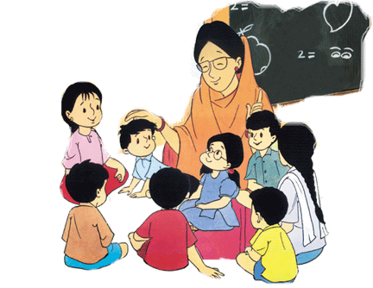
- Preliminary Session

- Session Objective: To welcome and introduce participants to the objectives of the training
- Methodology:
Greet the participants in a locally appropriate manner and welcome them to the training. Thank them for attending and explain that the training will help them in preparing for conducting a Meena class. The day’s programme would also be reviewed and any questions from the participants would be addressed.
Ask the participants what they expect to achieve out of this training. A Pre-training questionnaire may be filled out.
During the Ice Breaker, the teachers will be divided into pairs. Each pair will be given time to interact with each other and learn a few things about their counterpart. The partners will be then asked to introduce their counterpart to the macro group. This will continue till all the participants have been introduced.
The training film will be screened to provide a quick overview of what is to follow during the training.

c) Session Duration: 90 mins (includes 30 mins for Registration & 7 mins for showing training film)
d) Logistics/Instructional Material:
Stationery: Blank chart paper, marker pens, folders, note pads and pens. Training schedule. Pre-training questionnaire form. Training film.
e) Content Outline:
The ice breaker will:
- Create a positive group atmosphere
- Help people to relax
- Help people to get to know one another
- Break down social barriers
- Energize & motivate
- Help people to "think outside the box"
- Prepare them for learning activities in the sessions that follow

f) Summary Points:
Participants are welcomed and informed about the objectives of the training and the day’s training programme
An Ice Breaker helps participants to get to know each other and feel relaxed to train in a group.

- Session 1 – Overview of Meena Radio

- Session Objective: Participants understand the concept, objectives, content, implementation process and assessment of effectiveness of the radio program and are equipped to fulfill their roles.

The following objectives of Meena Radio will be communicated to the participants:
- Promote pro-social behaviours and practices
- Improve life skills and pro-social values, with an emphasis on gender and social inclusion
- Promote children’s and especially girls’ education with attention to enrolment, retention, quality, and literacy
- Endorse and model Child Friendly Schools
- Promote child rights among children and teachers

b) Methodology:

Participants will be given time to read the Meena Radio Concept Note as well as the Teachers’ Guidebook. Self reading will be followed by sharing key messages given in the two documents. One episode of Meena Radio will be played at the end of the session.
Participants will be informed about the broad goals of Meena Radio: (i) Child Rights (ii) Gender (iii) Child Friendly Schools
Participants will get an idea of the content map, broadcast schedule and the monitoring format. They will also be informed about the Meena Radio Success Stories and letters written by children.

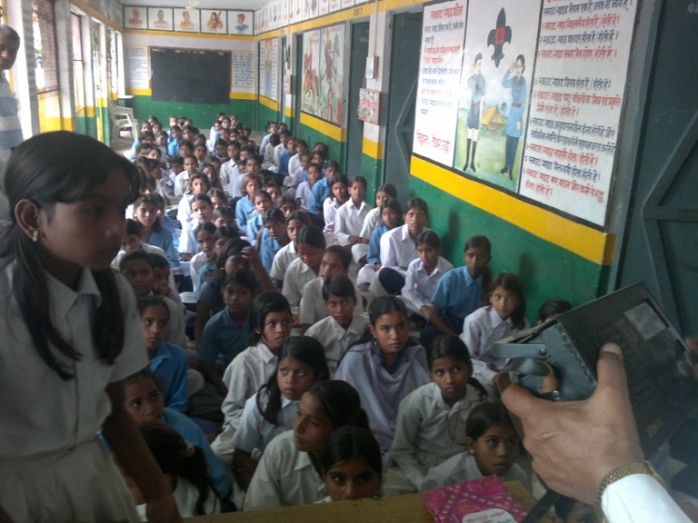
Teachers help students to enjoy the fun-filled learning experience!

- Session Duration: 90 mins.

d) Logistics/Instructional Material:

Power Point Presentation, Concept Note & Teachers’ Guide Book, Teacher’s Ready Reckoner and other IEC material (as applicable), Content Map and Broadcast Schedule, Poster, CD with Meena Radio episodes.
e) Content outline:

Background, Objectives, Content, Complete structure of the Program, Results of Baseline & Meena Effectiveness Study, Success stories and Meena Radio letters.
Role of Teachers in implementing the Meena Radio program.
Role of Teachers before, during and after the broadcast. Linkage with Meena Manch (or Meena Raju Manch) activities at School, if applicable.
Listening to the broadcast in micro groups, Group discussion and Preparation of role plays.
Role plays on Meena Radio classroom situations by participants.
Brain Storming, feedback & discussion.
f) Summary points:

- Primary audience: 11-14 yrs/Class VI-VIII
- 160 episodes (or selection from) on entertainment-education format
- Promoting pro-social behaviours and practices; Improving life skills and pro-social values, with an emphasis on gender and social inclusion; Promoting children’s -- and especially girls’ -- education with attention to enrolment, retention, quality, and literacy; Endorsing and modeling Child Friendly Schools

- Session 2 -- Role of Teachers

  - Session Objective:
Role of Teachers before, during and after the broadcast is understood, along with the linkage with Meena Manch (or Meena Raju Manch) activities at school.
b) Methodology:
Listening to the broadcast in micro groups, Group discussion & Preparation of role plays. Screening of training film.
c) Session Duration: 90 minutes.
d) Logistics/Instructional Material:
Teachers’ Guide Book, Teacher’s Ready Reckoner.
e) Content Outline:
Teachers will get a first-hand experience of listening to the Meena Radio episodes and will prepare a role play on real life facilitation of a classroom session on Meena Radio. This will help to build their capacity to implement the programme most effectively.
f) Summary Points:
Teachers are motivated and excited to understand and implement their role
Teachers get a first-hand experience of listening to the Meena Radio episodes
Teachers play out the classroom situation and are able to experience a new teaching system
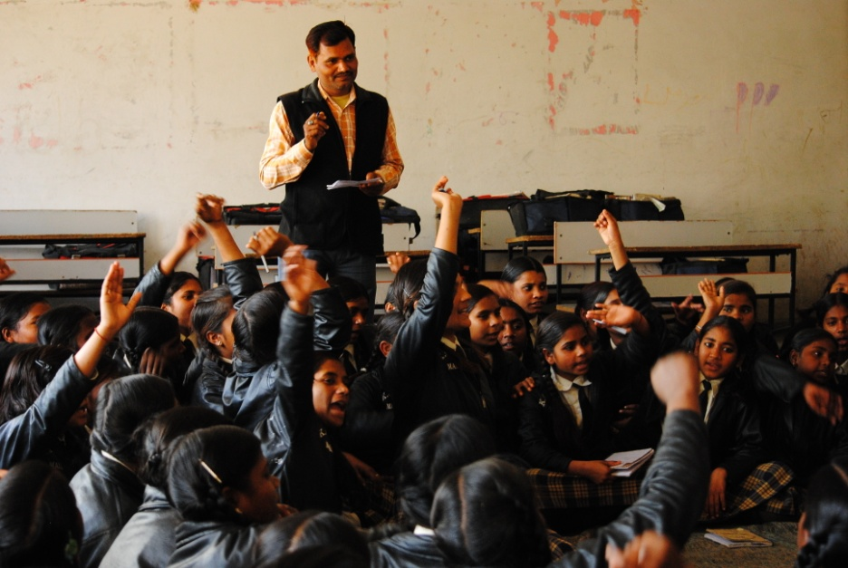
Teachers must encourage children to interact and share their experiences

- Create a session plan, which includes at least 5 minutes for questions and answers from the Meena story segment, 7–8 minutes to discuss the key issue and messages from the story and remaining 6–7 minutes for an activity (song, game or group work)
- Don’t begin the class just when the broadcast begins – Ensure that children have enough time to get seated comfortably in a position where they can listen clearly to the radio broadcast and also share their views with class mates. If necessary, re-arrange the classroom to make space for seating in front of the radio set. Probe for a recall of the previous episodes -- this will help students stay connected and focused to the next stage Ask students who want to drink water or use the toilet facilities to do so beforehand
- Ensure safe-keeping of the radio set and its maintenance
- Test the radio set before the broadcast and replace the batteries if needed. Keep a set of spare batteries handy
- Clearly explain what you expect from students such as discipline, active listening, and contributing to discussions and activities
- Keep material like paper, crayons, pictures etc. ready for planned activities
- During the broadcast, make notes of important messages, experiences, song tunes/lyrics or difficult words
- Don’t do all the talking. Instead, act like a facilitator and help children discuss issues among themselves, encouraging the children to speak
- There may not be one correct answer or one perfect solution to the challenges posed by the radio episode or related by a child in the post-broadcast interaction. Children need to be encouraged to explore all possible solutions
- Try to ensure that all the children have an equal to chance to participate and that the class is not always dominated by a few students
- Keep children focussed on topics emerging from the episode. However, if questions unrelated to the topics come up, don’t rule them out if they provide useful learning
- Remember that Meena Radio aims to improve the life skills of every child and therefore each child must come up with their own solutions to problems/challenges
- Ensure that children don’t get into arguments or make personal remarks related to gender, caste, religion etc
- Teachers need to build up their inventory of games and activities to keep the interest of children in the radio program at a high level
- Don’t end the class when the broadcast ends – Ensure that children have enough time to discuss what they have learnt and help them to make individual and group action plans
- Sum up points discussed while concluding
- Remind the students to assemble on time for the next day’s radio program. If teachers have the broadcast schedule, the theme for the next day’s broadcast may be shared with the students
- Teaching is an on-going and continuous process. It does not have to stop after the radio program ends
(For more Teacher’s Tips refer to Teacher’s Guide Page 22 and 27)

- Session 3 -- Role Plays (on classroom situations) & Wrap-up

- Session Objective:
To demonstrate how Meena Radio can be used effectively as a teaching/learning aid and how a teacher can add immense value and increase its efficacy.
Participants will learn all that they need to ensure before, during and after the broadcast of Meena Radio.
b) Methodology:
Brain storming, feedback & discussion. Presentation of the Role plays by the 4 micro groups
Vote of Thanks & Wrap up. Recapitulate the training’s learnings. Ask the participants for their feedback and suggestions for improvement. Thank them for their participation and wish them all the best for the important role that they will play for the radio program.
c) Session Duration: 120 minutes
d) Logistics/Instructional Material:
Teachers’ Guide Book, Teacher’s Ready Reckoner, Post-training assessment forms
e) Content Outline:
The teachers will understand that they need to discuss the issues highlighted in the story, help the children to identify their day to day real life challenges related to such issues as well as enable them to overcome such challenges.
Participants will be encouraged to train the other teachers as well as launch Meena Radio in their respective schools/districts with great vigour and enthusiasm.
Main activity:
- Enact a mock classroom – of students and teachers listening to a radio episode in a class room situation.
- Discuss the script of the role play in detail staying close to a real class room situation. Enact real situation, with real lines.
- A Post-training assessment.
f) Summary Points:
- Divide the participants in groups of 10-12 each.
- Each group may listen to two episodes of Meena Radio. They have to work on one episode, and comment on another group’s work on the other episode.
- Identification of a person in each group to play the role of a teacher must be done within the groups. For doing this, you may need to discuss what are the essential qualities of a teacher to facilitate this listening. (Rest of the group will enact roles of students)
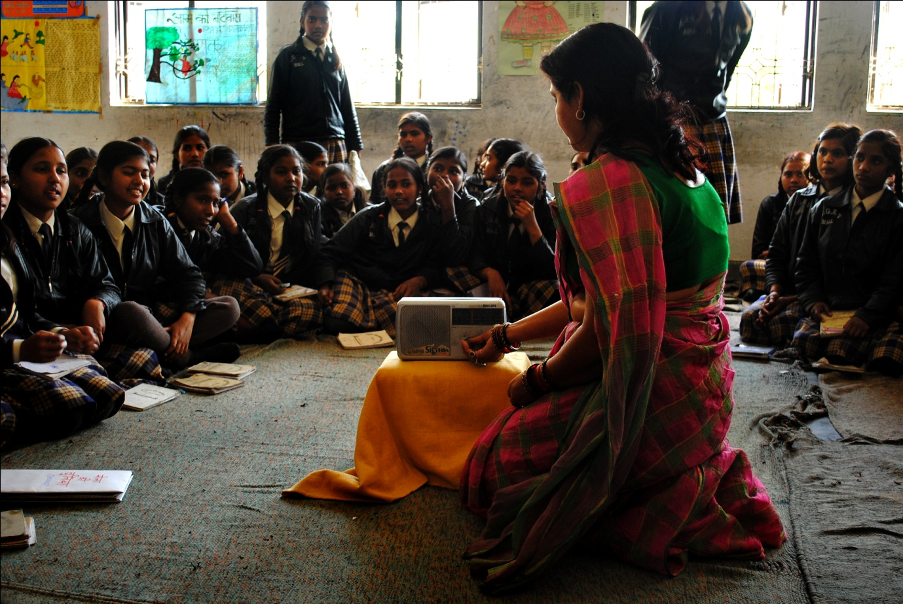
Trained teachers must conduct their class efficiently and help other teachers use Meena Radio

Wrap Up: During the Wrap Up, the trainers need to review all the main points that were covered during the training and the participants can ask any questions that they still have in mind. Hopefully, all the teachers who have been trained would now be excited to participate in the innovation EE radio program which is being implemented in their schools.

Best wishes for a successful training!

