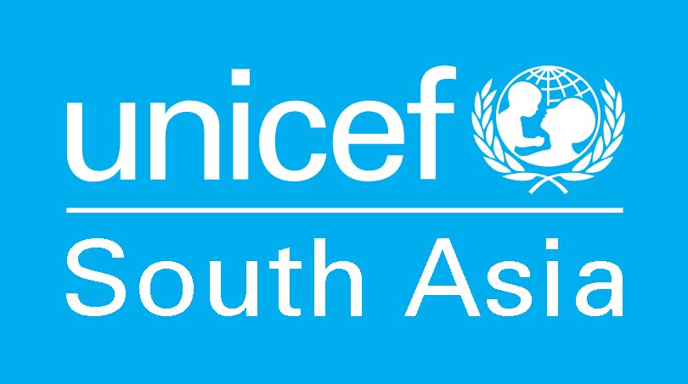
violence against children
Information Sheet | March 2020

Child Protection during COVID-19 Pandemic

High stress in family due to isolation, economic hardship or struggling to work remotely will likely increase risks of domestic violence and child abuse, including corporal punishment. During long school closure, children’s online activities may expose them to increased risks of online sexual abuse and grooming for sexual exploitation. Over time, economic vulnerability may lead to increases in child labour and other child protection issues.
- Providing information on a safe home environment
- Parenting support
- Mobilizing social service workforce and adapted case management and referral during the outbreak
- Mobilizing existing community-based child protection mechanisms
- Integrating MHPSS approaches/activities within the overall response strategies
- Consider social protection mechanisms in case of increased poverty
Key resources:
- Positive Parenting in COVID-19 Isolation Resource Pack
- Case management guidance for disease outbreak (Iraq Child Protection Cluster)
- Pakistan psychosocial support training in response to COVID-19 (UNICEF Pakistan)
- Briefing note on addressing mental health and psychosocial aspects of COVID-19 Outbreak Version 1.1 (IASC)
- Mental health and psychosocial support messages during the COVID-19 response (UNICEF EAPRO)
Other resources:
- Compendium of Case Management Tools and Resources (Global Social Service Workforce Alliance, 2018)

The purpose of this information sheet is to share and exchange information among UNICEF staff in South Asia working in Child Protection during the COVID-19 pandemic. For any queries and/or additional information and resources to be included on the information sheet, please contact the UNICEF Regional Team at rosacp@unicef.org. We welcome your inputs anytime. Thank you.


UNICEF Regional Office for South Asia
Tel: +977-1-4417082 | Email: rosacp@unicef.org

