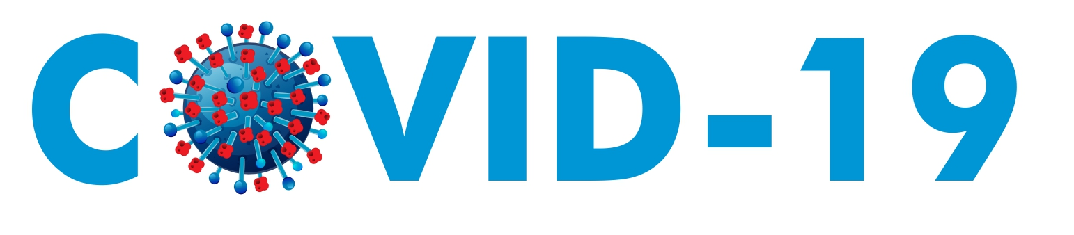
UNICEF India Child Protection Guidance

Priority intervention and impact on programmes

Implications of COVID-19 on Child Protection
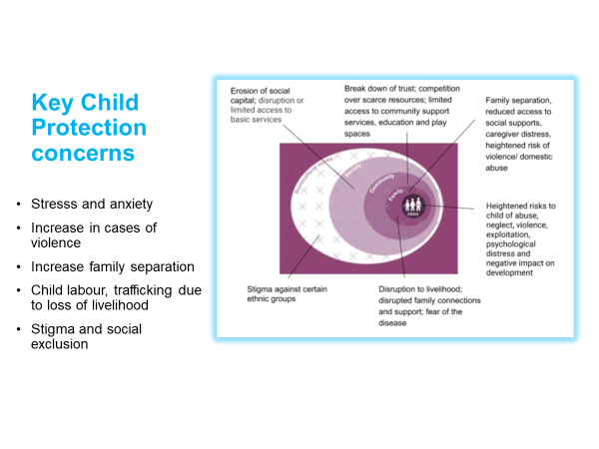

Priority interventions for COVID-19
As indicated in the note shared on 16/March with the Network, priority interventions for CP are:

- Systems, including prevention and response of violence
- Support development and roll out of capacity building interventions for ICPS functionaries, following the FlW experience.
- To support CWCS, JJBs and DCPU to function remotely and also monitor the situation
- Strengthen engagement with the Police, as one of the only actors on the ground.
- Continuation of the prevention and response to violence work, and inclusion of this within the preventive messages.

- PSS
- Develop a PSS package for CHILDLINE and other CP front line workers, and support roll out with CHILDLINE.
- Partnership with NIMHAS for development of specialized package for children directly impacted (by quarantine, isolation, etc).
- Partnership with NIMHAS and possibly with Indian Psychiatric Society (IPS) for development of specialized package for Health Care Workers (HCWs).
- Support MoHFW in partnership with WHO for the development of MHPSS Framework for COVID19 Response.
- Coordination with Education on PSS support through school platforms (in the longer term).

- Care
- Supreme Court order on protection of children in alternative care to be followed, and guidelines for preventive measures for children in CCIs, to be collated to be widely disseminated and enforced.
- Special attention to be provided to children from CCIs and/or Observation Homes that have been released/discharge. In the longer run, UNICEF should advocate for best interest assessments to be conducted in case some of these can reunified or placed in foster or kindship care arrangements.
- Activate mechanisms for identification and support of children that are rendered without parental care (temporary or long term).

- Children on the Move
- Rapid assessment of migrant populations with emphasis on children. Ideally, work towards institutionalization of migration tracking system at Panchayat level.
- Inclusion of critical child protection services, including PSS, in shelters and camps, and support vulnerable children and families accessing relief packages where available. Consider working with Police, CHILDLINE and/or other CSO stakeholders.
- Through ICPS system (including CHILDLINE) work towards prevention of family separation and provision of family tracing and reunification services.
- Support efforts towards portability of rights of migrants, linkages of migrant children and families with social protection schemes, and broader rehabilitation and resettlement efforts.
- Work with State Government towards the ‘continuum of services’ and provisions for portability of rights of migrants. In the longer run, support broader rehabilitation and resettlement efforts.
- Work with SP for the linkages of these children to social protection schemes.

- Adolescent and Youth Engagement (Full ADAP guidance here)
- Generate information and voices of young people: (i) Use U- Report and social media platforms to generate information on the practice and views of adolescents to inform the COVID-19 response including questions on the engagement of adolescents and youth in situation analyses, needs assessments and emergency response and (ii) Make this information available to advocate to policy makers, schools’ authorities, and community leaders to address adolescent and youth needs in the next phase of the response.
- Engage with UN agencies including UNFPA, UNDP & UNV for joint action to digitally mobilize young people towards action. Some of the initiatives identified are volunteering platform with UNV, Youth Innovations and Appreciative Inquiry to creatively engage young people as part of COVID response and resilience.
Areas of convergence
Multisectorial approach should be at the core of the COVID19 response. The areas below are the ones more critical, but general coordination across sectors should go beyond these priority areas. State colleagues are encouraged to share this with relevant sector colleagues and CFOs to ensure convergence.
CP Area | Sector of convergence | Priority intervention
Systems | C4D  DRR  Gender | Adaptation of FLW to ICPS functionaries, inclusion of C4D/PSS and other CP messages across community engagement platforms  Collaboration NDMA training  Preventive and response messages on EVAC
PSS | Health  Education | Support PSS for HCWs  Potential use of PSS basic package for teachers/school platforms
Care | Health  SP | Inclusion of referral systems for children in need of alternative care/ protection to the CPS /SW system.  Support SP/Schemes/cash transfer schemes for children without parental care, unaccompanied or separted
Children on the Move | DRR (and other sectors)  SP | Collaboration for the provision and/or referral of children in shelter and camps to CP critical services.  Linkages of vulnerable children and adolescents, specially CoM, with social protection schemes.
ADAP | C4D, CAP, T4D  SP  Education | Development of materials and interventions for youth/adolescent engagement, including through UReport and Rapid Pro.  Support the ADAP component of SP vulnerability map  Cash plus interventions for adolescent girls
*Collaboration with CAP and C4D will cut across the CP programme

Summary of packages that will be used for COVID-Response as follows:
 | Packages | Other key materials | Key global/regional references
CARE |  | Guidance for CCIs  Supreme Court Order | Care guidance  Children in detention
PSS | PSS activity level package  NIMHAS specialized package children affected  NIMHAS specialized package for HCWs |  | MPSS updated guidance
Systems | CP FLW package  NDMA training package |  | CP Global alliance
ADAP |  | U report assessment  Adolescent and youth engagement materials | ADAP  Toolkit for Young People
Children on the Move |  | C4D materials (adapted from global level materials) | Tools and materials

Key resources
The key resources are all filed in these two repositories:
- CP India Resources (including global resources disseminated)
- COVID-19 Risk Comms (includes all India specific RCCE/SBBC materials)

Funding requirements

 | Funds that can be reprogrammed | Additional funds required | Total funding
Systems and PSS  (Output 1) | 200,000 | 225,000 | 425,000
Care  (Output 2) | 195,000 | 125,000 | 320,000
Children on the Move (Output 2) | 50,000 | 100,000 | 150,000
ADAP  (Output 3) | 15,000 | 150,000 | 165,000
TOTAL | 460,000 | 600,000 | 1,060,000

These are the latest estimations. State needs are reflected in the COVID CP Actions and Impact link . The above is likely to require adjustments as the situation evolves. In terms of reprogramming, discussions are ongoing for reprogramming. There may be funding opportunities that may allow CP to revise the funding requirements upwards.

Monitoring and Reporting
The following indicators shall be taken into considerations for monitoring the COVID response program. Metadata for all the indicators were developed which include, definition, MOV, desegregations, measurement units, reporting frequency etc. Reporting form state office to country / Delhi office shall be done using RAM. Additionally, a separate tool been developed to capture / record data flow from partners level to state office. The ones in bold are the ones that are part of global HPM and thus will be used in external sitreps.

Indicators | MOV | Target
# of Adolescent and youth reached with targeted messages and information on prevention to Covid 19 | Digital platform and Offline through partnerships/Networks | 400,000
# of child protection functionaries reached through training with key messages on prevention and protection of children for Covid 19 | Reports from states and Childline | 10,000
# of children and caregivers receiving mental health and psychosocial services during the Covid 19 crisis. | Children in CCIs reached through Childline / CP functionaries using PSS package;  Children who were provided support through CCC | 65,000
# of children and caregivers in institutions/ foster care that have received information on prevention and response to Covid 19 | NGO and Childline and respective state departments (DWCD/ SJE) | 200,000
# of children left without parental care provided with appropriate alternative care arrangements | CWC and JJB orders/records for admissions into institutions, In-take registers of institutions | 500

Impact on Programme: what will continue, what will be affected in the next 2-3 months.
While COVID19 interventions will be prioritized, the following programme activities will be continued:

Continue
- Priority interventions mentioned above.
- Development of packages of materials and trainings, especially those that can contribute to the four pillars of the CP COVID19 response.
- Support RCCE interventions on COVID19 through existing partnerships, especially Multistate partnerships.
- Continuation of interventions that do not require field presence, including formulation of evidence work, finalization of resource mobilization initiatives, preparation of partnerships, development of EVAC strategy.
- MTSR review will continue (balancing the workload).

Suspended
- All meetings, trainings, and large gatherings, unless can be organized remotely.
- Community based interventions, such as Child Friendly Spaces, adolescent group and parents/community meetings.
- New partnerships, unless directly relate to COVID19 response.
- Field work related to evidence and research.

PCA and DCT management:
- Adherence to Government guidelines and instructions in terms of field implementation, social gathering etc. Discuss reprioritization of activities focusing on those that do not require social gatherings.
- Revise PCAs agreements to consider what interventions can be geared/contribute to COVID19 response.
- Start working now on existing DCT and PCAs to ensure smooth implementation and avoidance of delays, and work on adjustments to avoid delays in liquidation.
- Advance the formulation of PCAs and DCTs but put on hold PCAs/DCTs that have not yet been signed and not directly related to COVID-Response.
- Discuss with partners the situation and consider no-cost extensions if needed.
- Exert duty of care: ensure dissemination of available information that can be useful for prevention of COVID19, show care and support through communications and interactions.

ANNEX: DETAILED MAPPING ON INTERVENTIONS PRIORITIZED/SUSPENDED AFFECTED

Output 1

The following activities will continue as planned, in addition to the COVID-19 related ones:
- Psychosocial support, including development of materials
- Social workforce development – finalization of modalities of contracting or PCA and initiation of partnership. Briefings and desk review work can be initiated on this.
- Childline partnership – planning of the next phase of activities and work on development of roll out of activities at their level will continue. In addition the NASSCOM support for development of a case management software will also be followed up and done without need for much physical or one to one meetings
- Evidence - advance ToR development and preparations of the EVAC secondary analysis study and Systems Evaluation.
- Work with MWCD and NIC on CPIMS on development will continue
- Engagement with Judiciary in 2020 preparations will continue, the physical meeting planned in April may shift to a virtual one.
- Discussion with Cyperpeace on next phase of partnership will continue
- EVAC – strategy finalization and implementation of key pieces including alliance for EVAC, Facebook proposal, POCSO training support, EVAC Comms strategy

Areas that will be affected/delayed/suspended:
- ICMEC Forum on Law Enforcement and Online Child Protection postponed
- Consultation on CP Systems evaluations postponed.
- Delhi response work to follow government advisory. Community visits to continue, establishment of CFS in Delhi will be based on the advice by Delhi government.
- JJ Committee meeting scheduled for April might be suspended, VC to be explored.
- POCSO training might be delayed. Films on POCSO – agency to travel to states- to check with agency if travel will continue otherwise focus on taking clips/videos from Delhi

Output 2

The following activities would continue as planned:
- Preparatory work on CL/CoM activities will continue: finalize the TOR for the DFID study, Monitoring Matrix, Training Manual.
- SOS - The curriculum for children in institutions with SOS will be developed (but see below)
- Udayan Care - Remote calls for PCA development will continue.
- Butterflies- The IACN network work will continue. We have a remote meeting planned on the 3rd.
- Note on Residential Care with Education will be delayed to be continued
- Resource mobilization: concept note and coverage data for output 2 US Fund proposal will be completed

Areas that will be affected/delayed/suspended:
- DFiD CL/CoM: interstate meeting possible postponement, support to the Child Labour communication strategy deferred.
- SOS: travel to states for training will be delayed
- Delia Pop’s (Hope and Homes) visit postponed and learning event in Assam; Miracle foundation trainings will be delayed, annual review will be done remotely, and physical reviews postponed in Gujarat and Maharashtra for now.
- The travel to states for documentation of promising practices will be delayed.
- Karnataka pilot with CCIs may be postponed.

Output 3

The following activities will continue as planned, in addition to the COVID-19 related ones:
- Joint planning of GPECM Phase 2 with UNFPA
- Cash Plus note reframing
- MTSR work on CP Sector and Adolescent Beam
- National partnership (NCCDC) to continue backend work on SBCC paper to capture the inter-linkage between KI mapping, CGA, Tarunya Package and ToT
- Meeting in small group with specific line departments to continue at district level (keeping in mind the COVID19 precaution guideline) under the multi-state partnerships (CRY, MAMTA, AAA)
- NCIS to continue work on BBBP assignment support (translation and E-book)

Areas that will be affected/delayed/suspended:
- Workshop on Child Labour and EVAC (communication strategy development)- focused on realistic intervention cost plan at the district to be deferred
- Trainings on the Tarunya Tool Kit and CP SMART Kit scheduled for April-May, to be deferred until change in situation
- IKEA Impact evaluation planned for April-May, to be deferred. ROSA, ICO and UOM will continue the backend work on planning, study design and question tools.
- BBBP Master trainers’ trainings planned for April-May 2020 for the govt functionaries to be deferred.
- NCIS led KM & documentation contract till June 2020- March travel to Jharkhand, Assam in April; deliverables to be pushed/ delayed, as travel cancelled for the time being
- Validation of SAP in states might be delayed as discussion with government officials pushed
- CYC trainings with NSS & NYKS & Youth Collective trainings on Jagrik toolkit on hold till 31st March
- J&K community-based interventions- functioning of CFS & ARC- to follow govt instructions. Certain interventions to continue if government has given consent and agreement.
- Vulnerability Mapping study in two districts of West Bengal scheduled in March postponed till 31st March

Refer to UNICEF’s Adolescent Development and Participation Knowledge Domain and the University of California, Berkeley’s Youth Participatory Action Research Toolbox.

